Total Score
_______ / 42 points

B Complete the paragraph with the correct noun or adjective form of the words in parentheses.
Rachel is the most ____talented_________________ (talent) young musician I know. She plays
the violin with a lot of ____confidence_________________ (confident), and she shows great
¹

__enthusiasm___________________ (enthusiastic) for classical music. Her friend Michele is studying
²

to be an actress. Michele’s acting teacher says her work shows great __creativity__
³

(creative) and ____flexibility_________________ (flexible) because she can act in both comedies and
⁴

dramas. I really admire the ______dedication_______________ (dedicated) of these young women.
⁵

B _______ / 6 points (1 point each)
⁶

C Complete the sentences with the correct phrases from the box.
give it back  pay it back | point it out  put it off | try it out  turn it down
1. I really don’t want the job. I’m going to __turn it down___________________.
2. Which is your car? Can you __point it out___________________?
3. Have you finished my book yet? If you have, could you _ __ give it back _______, please?
4. Anna lent me some money last week. I need to _____pay it back________________, or she’ll be upset.
5. I’m very busy, so I’m not going to take my vacation this month. I’m going to
___put it off__________________ for a while.
6. I’ve ordered a new cell phone. I can’t wait to ___ _ try it out _______.
C _______ / 6 points (1 point each)

D Complete each sentence with the correct reflexive pronoun.
1. Can you and Carlos work by __yourselves_______________ or do you need help?
2. She bought some CDs and books and taught ______herself___________ a little French
before she went to Paris.
3. After the movie, they bought __themselves_______________ some ice cream.
4. Do you consider ______yourself___________ a generous person?
5. Last year, I traveled to Chile by ___myself______________.
6. Our vacation was awesome. We really enjoyed ___ourselves______________.
D _______ / 6 points (1 point each)
E Complete the second conditional sentences with the words in parentheses and the correct form of the verbs. Use contractions where possible.
1. If ___you lent____________________________ (you / lend) me the money I need,
_you’d not be __________________________ (you / not / be) sorry!
¹

2. ____You’d make___________ (you / make) a doctor’s appointment for me
²

if __I asked___________________ (I / ask) you to?
³

3. If _you didn’t be_________________ (you / not / be) so shy,
⁴

You’d have__________________ (you / have) more friends.
⁵

4. What ___would you do_____________ (you / do)
⁶

if __you didn’t have___________ (you / not / have) school today?
⁷

E _______ / 8 points (1 point each)
⁸

F Check () the two correct sentences to complete each conversation.
1. A: I’m going to buy a new car.
B: You don’t have enough money. ____
a.  I’ll give it some thought.
b.  I don’t think you should do that.
c.  I’m not sure that’s the best idea.
2. A: That bike is $600. It’s too expensive for you.
B: You might be right. ____
a.  I’ll think about it.
b.  I’ll see.
c.  I wouldn’t recommend it.
F _______ / 4 points (2 points each)

G Read the article. Check the correct answer for each question.
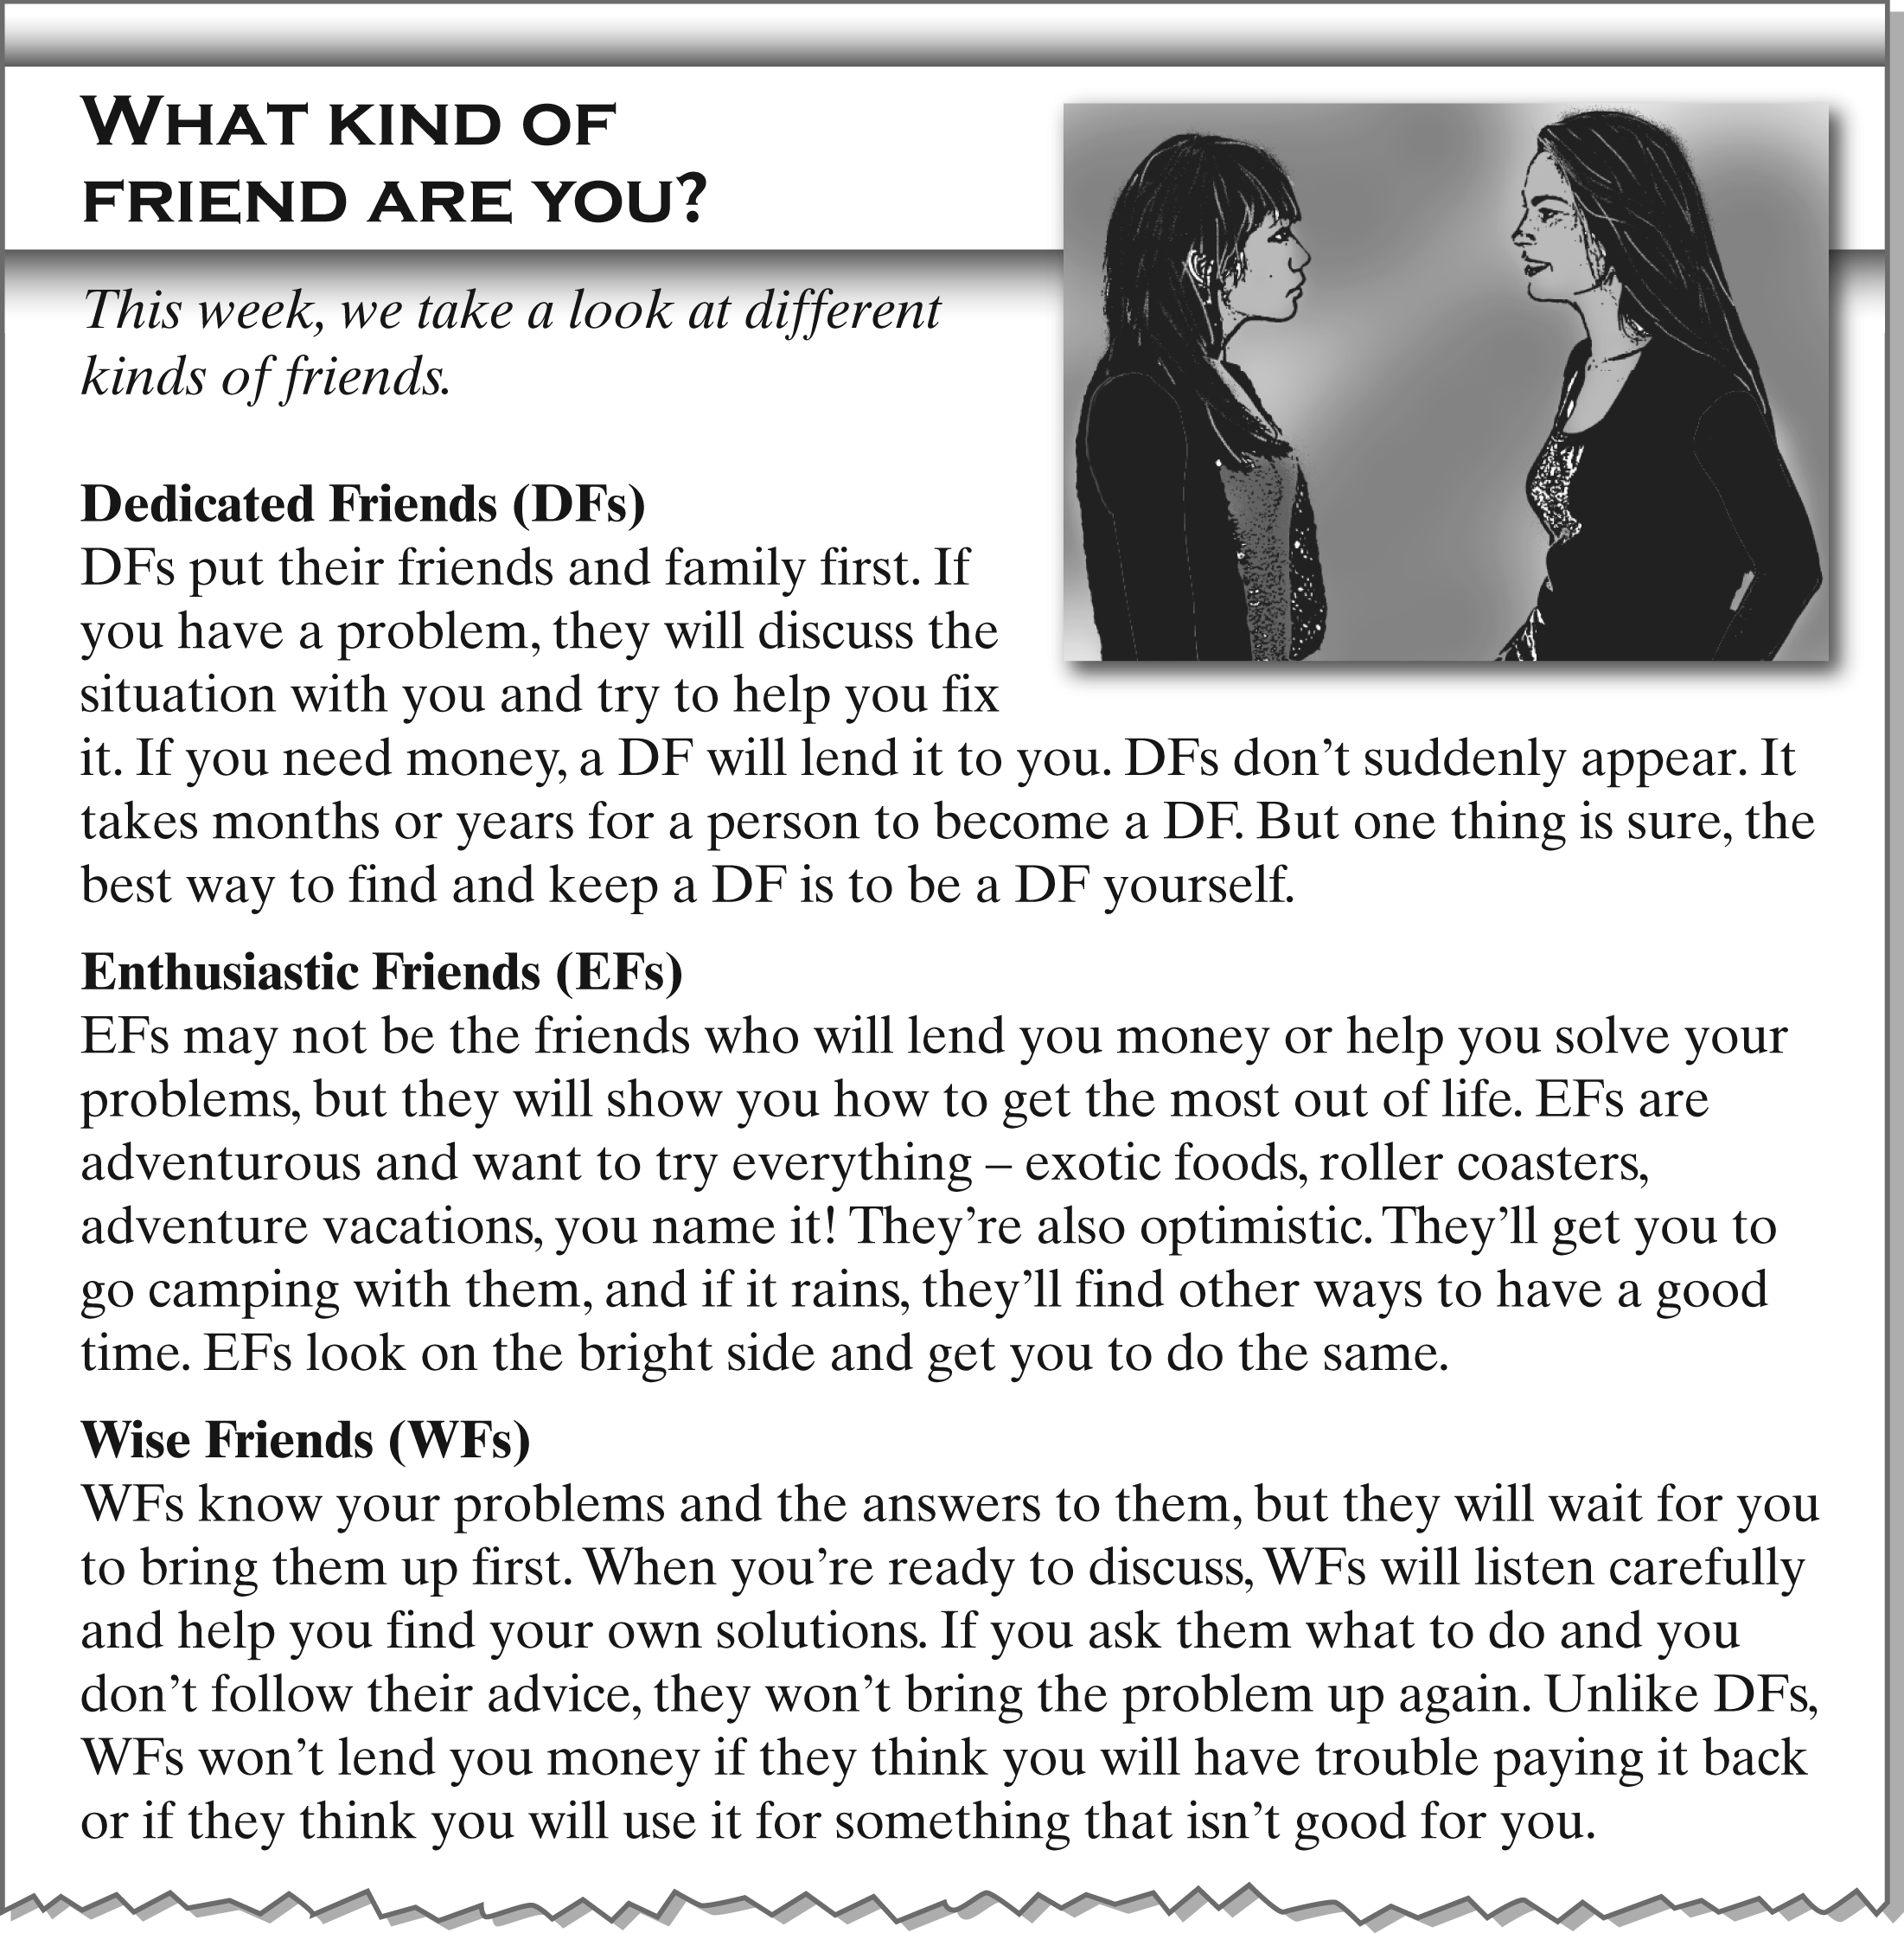
In the writer’s opinion, which kind of friends . . . ? | DFs | EFs | WFs
1. won’t discuss your problems if you don’t mention them first |  |  | 
2. are easier to find if you are this kind of friend yourself |  |  | 
3. are the most fun |  |  | 
4. would probably lend you money if you couldn’t pay it back |  |  | 
5. might not be very interested in talking about your problems |  |  | 
6. will try to help you help yourself |  |  | 
G _______ / 12 points (2 points each)

